FUNCTIONAL AND PERFORMANCE TESTING :
DATE | 04-11-2025
TEAM ID | NM2025TMID00191
PROJECT NAME | Streamlining Ticket  Assignment For Efficient Support Operations

MILESTONE -8 FLOW

ACTIVITY-1 Create a Flow to Assign operations ticket to group

PURPOSE:
Purpose of Creating a Flow to Assign Operations Ticket to Group: The purpose is to automate the process of directing operations-related tickets to the right support group.

USES:
It automatically routes operations tickets to the correct group, speeding up ticket handling and improving support efficiency.

STEPS:

- Open service now.
- Click on All >> search for Flow Designer
- Click on Flow Designer under Process Automation.
- After opening Flow Designer Click on new and select Flow.
- Under Flow properties Give Flow Name as “ Regarding Certificate”. 6.Application should be Global.
- Select Run user as “ System user ” from that choice.
- Click on Submit.

- Click on Add a trigger
- Select the trigger in that Search for “create or update a record” and select that.
- Give the table name as “ Operations related ”.
- Give the Condition as Field : issue
Operator : is
Value : Regrading Certificates
- After that click on Done
- Now under Actions.
- Click on Add an action.
- Select action in that search for “ Update Record ”.
- In Record field drag the fields from the data navigation from left side
- Table will be auto assigned after that
- Give the field as “ Assigned to group ”
- Give value as “ Certificates ”
- Click on Done.
- Click on Save to save the Flow.

- Click on Activate.
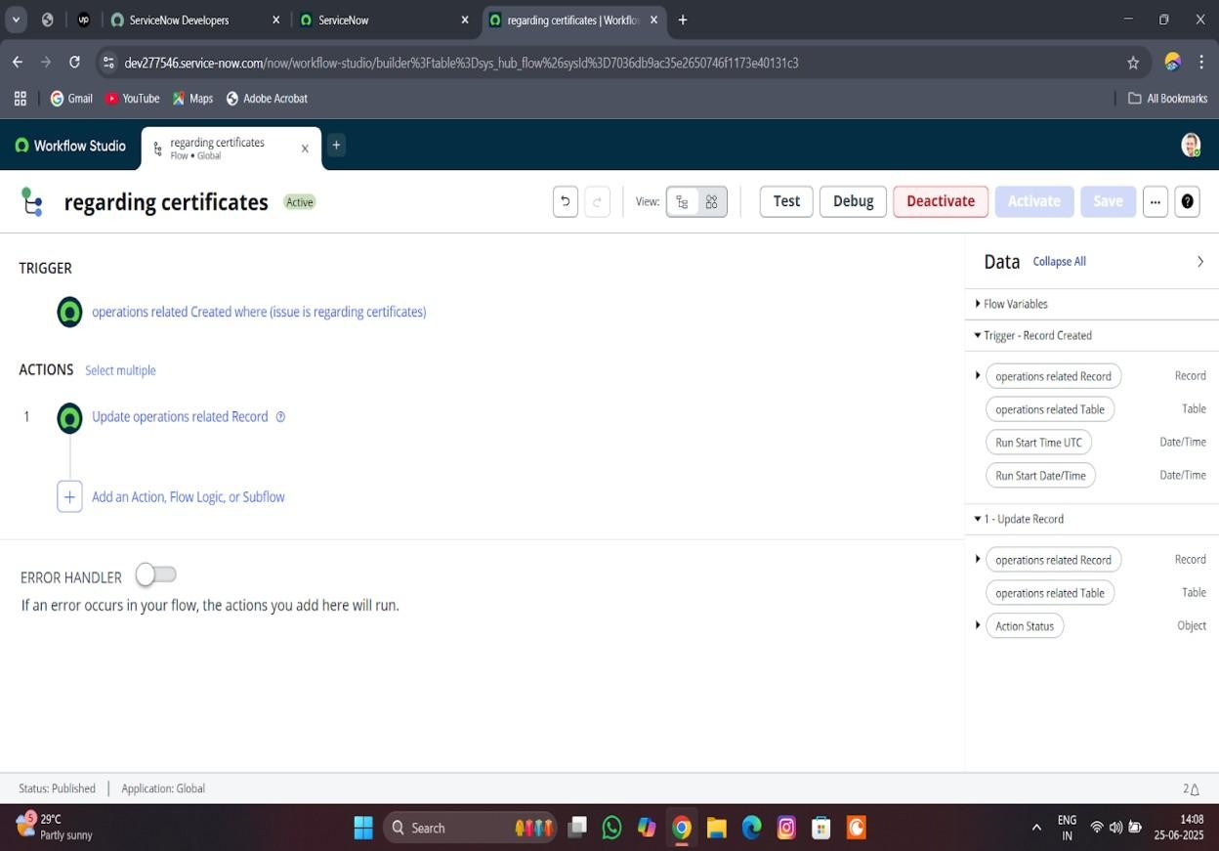

ACTIVITY-2 Create a Flow to Assign operations ticket to Platform PURPOSE:
To automatically assign operations tickets to the right platform experts, ensuring faster and accurate support.

USES:
It routes operations tickets to the correct platform specialists automatically, improving response time and support accurate

STEPS:
- Open service now.
- Click on All >> search for Flow Designer
- Click on Flow Designer under Process Automation.
- After opening Flow Designer Click on new and select Flow.
- Under Flow properties Give Flow Name as “ Regarding Platform ”. 6.Application should be Global.
- Select Run user as “ System user ” from that choice.
- Click on Submit.

- Click on Add a trigger
- Select the trigger in that Search for “create or update a record” and select that.
- Give the table name as “ Operations related ”.
- Give the Condition as Field : issue Operator : is
Value : Unable to login to platform
- Click on New Criteria Field : issue Operator : is
Value : 404 Error
- Click on New Criteria Field : issue Operator : is
Value : Regrading User expired
- After that click on Done.
- Now under Actions.
- Click on Add an action.
- Select action in that search for “ Update Record ”.
- In Record field drag the fields from the data navigation from left side
- Table will be auto assigned after that 13.Give the field as “ Assigned to group ”. 14.Give value as “ Platform ”
- Click on Done.
- Click on Save to save the Flow.
- Click on Activate.

